Network Security and Database Vulnerabilities

1. **Week 1**

[**https://cve.mitre.org/**](https://cve.mitre.org/)

[**https://nvd.nist.gov/general**](https://nvd.nist.gov/general)

[**https://hub.packtpub.com/penetration-testing-rules-of-engagement/**](https://hub.packtpub.com/penetration-testing-rules-of-engagement/)

[**https://securitytrails.com/blog/google-hacking-techniques**](https://securitytrails.com/blog/google-hacking-techniques)

[**https://www.sans.org/reading-room/whitepapers/bestprac/paper/33343**](https://www.sans.org/reading-room/whitepapers/bestprac/paper/33343)

[**https://www.kali.org/docs/introduction/what-is-kali-linux/**](https://www.kali.org/docs/introduction/what-is-kali-linux/)

[**https://www.freecodecamp.org/news/keep-calm-and-hack-the-box-lame/**](https://www.freecodecamp.org/news/keep-calm-and-hack-the-box-lame/)

[**https://nmap.org/book/man.html#man-description**](https://nmap.org/book/man.html#man-description)

[**https://www.wireshark.org/#learnWS**](https://www.wireshark.org/#learnWS)

[**https://cybersecurity.att.com/blogs/security-essentials/incident-response-steps-comparison-guide**](https://cybersecurity.att.com/blogs/security-essentials/incident-response-steps-comparison-guide)

[**https://www.sans.org/reading-room/whitepapers/incident/practical-incident-response-network-based-attack-37920**](https://www.sans.org/reading-room/whitepapers/incident/practical-incident-response-network-based-attack-37920)

**https://www.cynet.com/blog/the-7-best-free-and-open-source-incident-response-tools/**



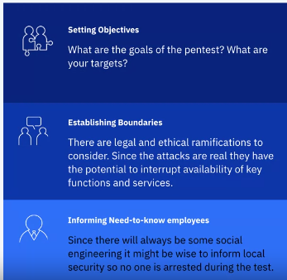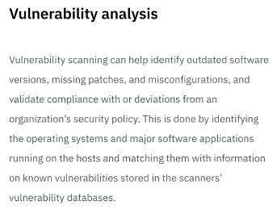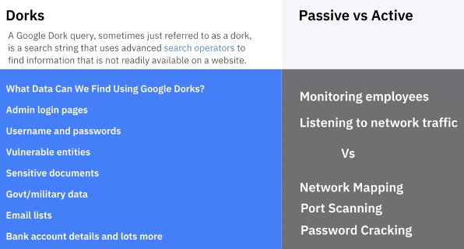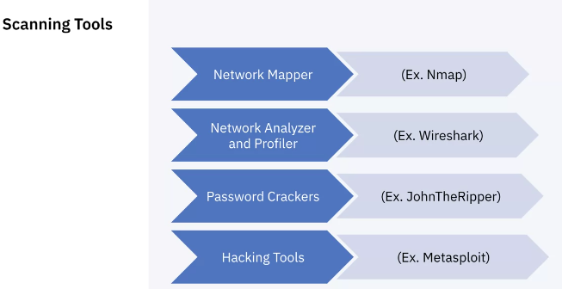

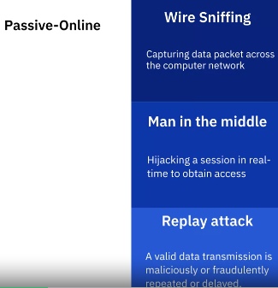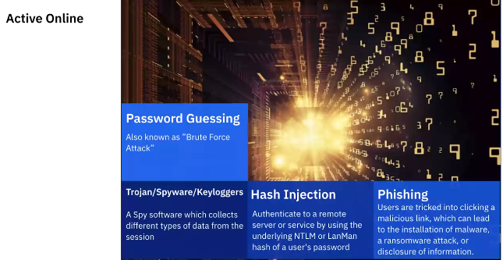

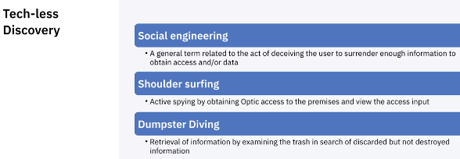

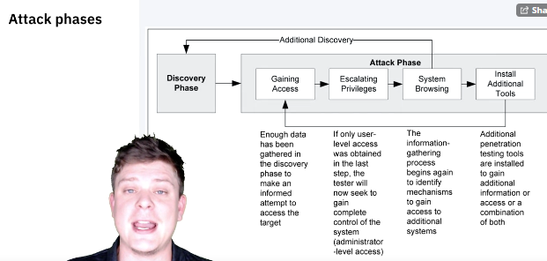

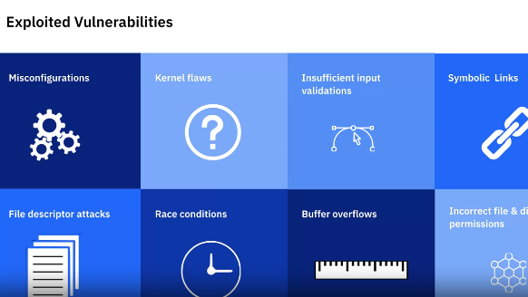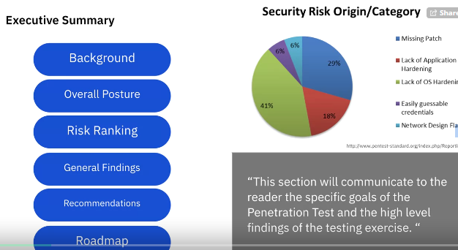

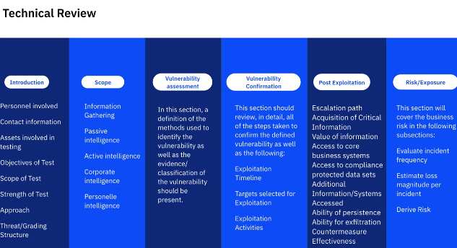

1. **Week 2**

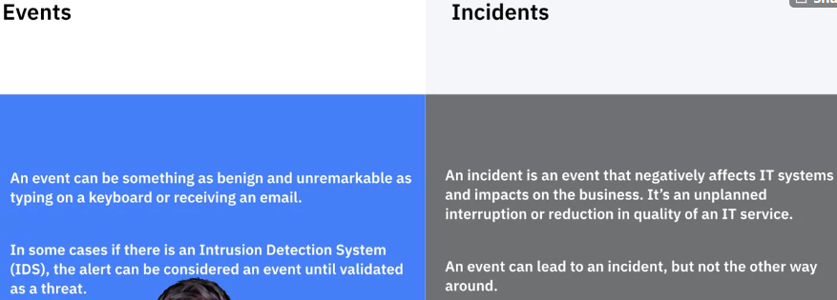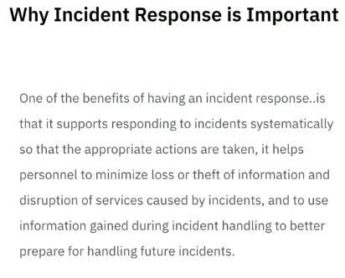

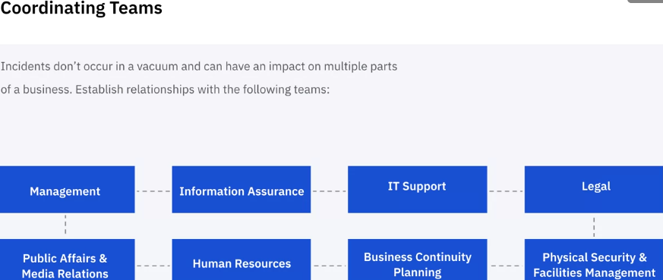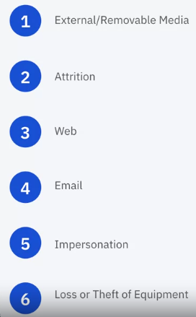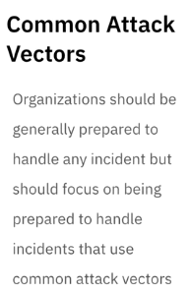

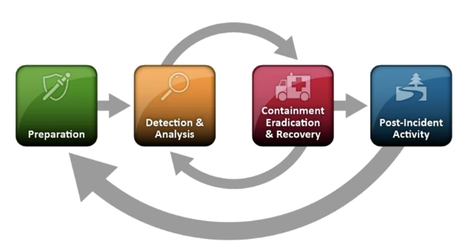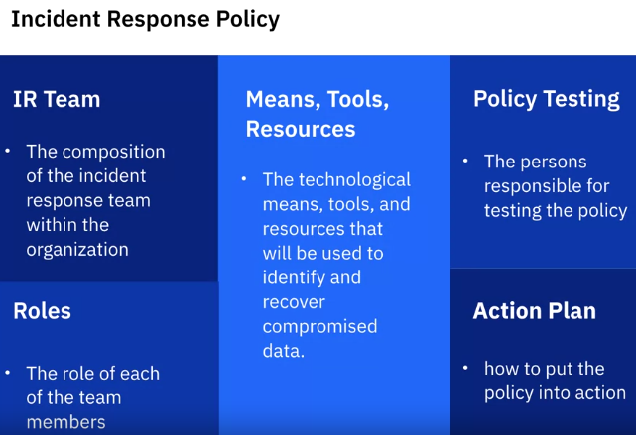

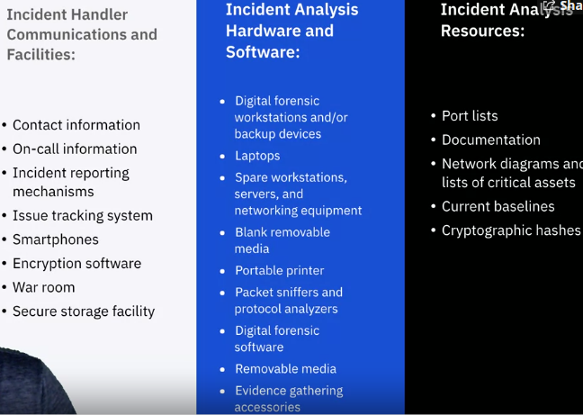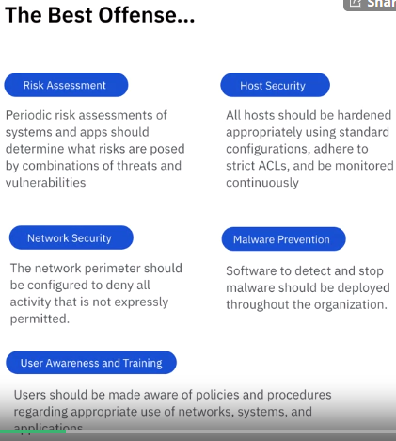

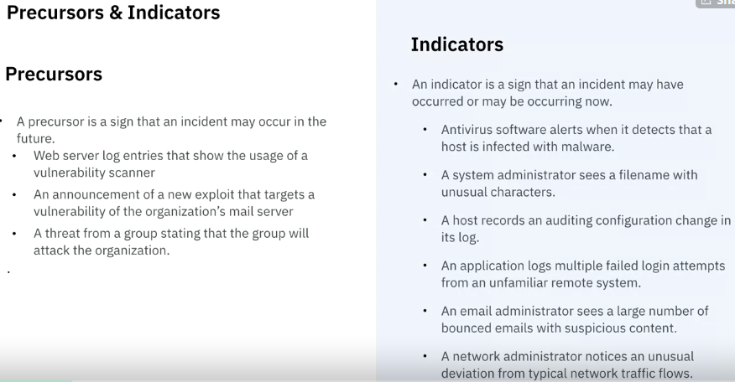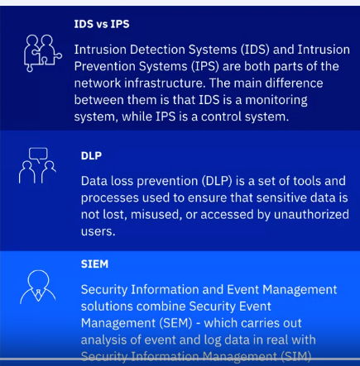

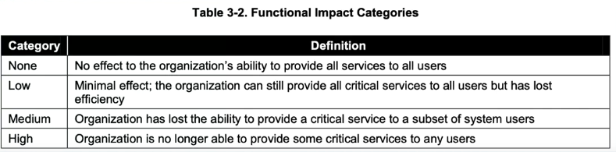

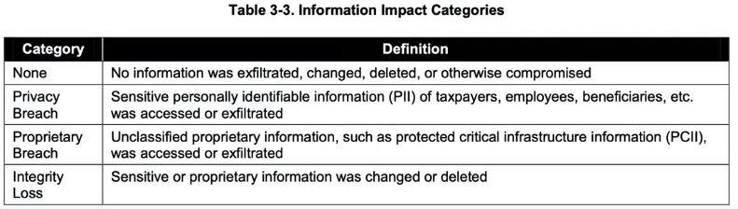

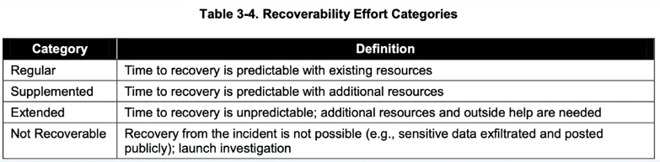

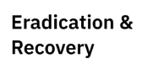 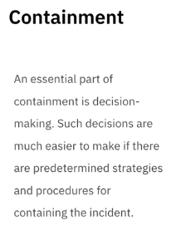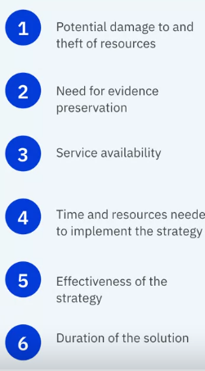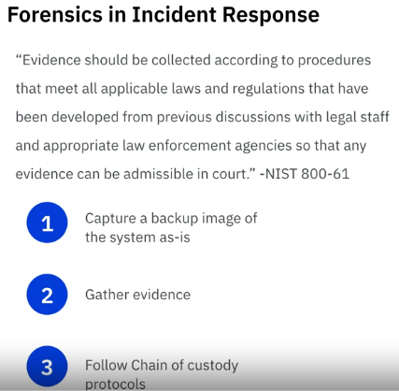

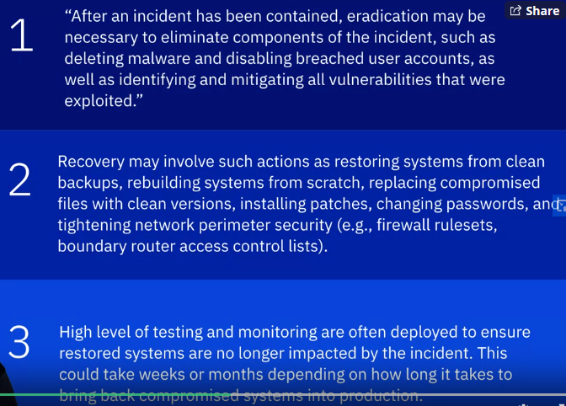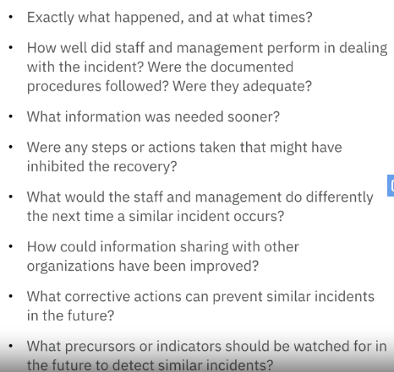

https://www.securitylearningacademy.com/local/navigator/index.php?level=cvl001

1. 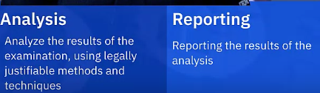**Week 3**

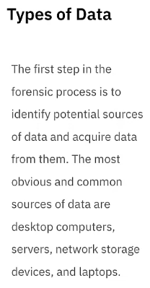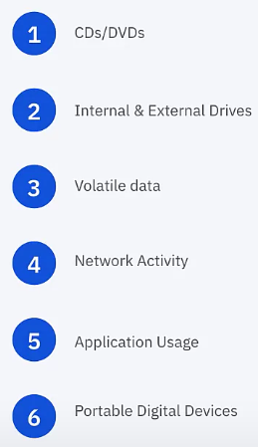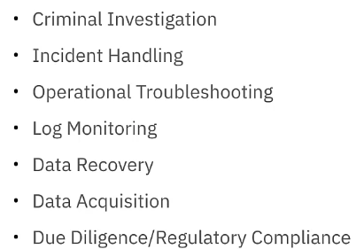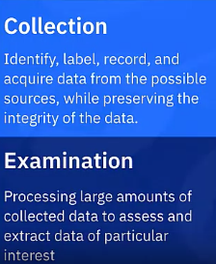

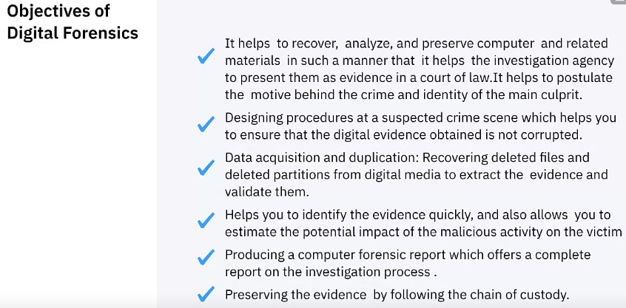

1. **Week 4**